# CS 499 Module One Assignment – Michael Zietz

Complete this template by replacing the bracketed text with the relevant information.

1. **Self-Introduction:** Address all of the following questions to introduce yourself.
   * **How long have you been in the Computer Science program?**

Over the past two years, I’ve been an active student in Southern New Hampshire University’s computer science bachelor’s program with a concentration in software engineering. I previously received my associates degree in computer science from Delaware County Community College in 2020 before pursuing this program in 2022.

* + **What have you learned while in the program? List three of the most important concepts or skills you have learned.**

While progressing through this program, I learned many critical skills for become a successful software engineer. Here are the three that stand out to me the most:

1. Problem Solving – Through countless projects I successfully delivered, I was required to think outside the box for solutions to many coding problems. Learning new languages and applying coding concepts to tasks built a firm foundation in my critical thinking skills and problem solving.
2. Full Stack Web Development – Before this culminating course, I completed CS-465 Full Stack Development which introduced the concept of functional web design. Through study and application of primary course objectives, I had the opportunity to create robust web pages that utilized industry standard concepts. The most prominent of these being MEAN, which stands for MongoDB, Express JS, Angular JS, and Node JS.
3. Rearching – During this program, I have been tasked with solving problems that, at the time, were outside my current skill set. Through practice and determination, I gained the ability to research new methods of solutions to solve new sets of problems and expand my programming skills. Not only was I tasked with discovering these solutions, but I was also responsible for verifying the information came from credible sources that did not pose a risk to the rest of the code base.
   * **Discuss the specific skills you aim to demonstrate through your enhancements to reach each of the course outcomes.**

I aim to demonstrate all three of these skills in addition to applying my surrounding computer science knowledge and communication skills to achieve each of the course outcomes. I will have to problem solve to find solutions to issues I have not been exposed to, I will have to manage time well to accomplish all tasks within the targeted time frame or sprint, I seek to grow and deploy my full stack development skills in the following enhancements, and I will have to research to continue to grow my skills as a developer to be able to tackle more unique problems but also deploy current safety practices.

* + **How do the specific skills you will demonstrate align with your career plans related to your degree?**

These skills mentioned are exactly what I believe are necessary to make a successful software engineer in the professional work force. I aim to utilize them to become an asset to any development team I join to not only create functional applications but also benefit all users and stakeholders involved.

* + **How does this contribute to the specialization you are targeting for your career?**

A software developer needs these skills in order to produce assigned tasks and eventually finished products that satisfy all requirements. In addition to technical skills required to complete required tasks, I will also need to deploy communication skills concerning tasks at hand with employers, coworkers, clients, and other stake holders to ensure I deliver all expectations.

1. **ePortfolio Set Up:**

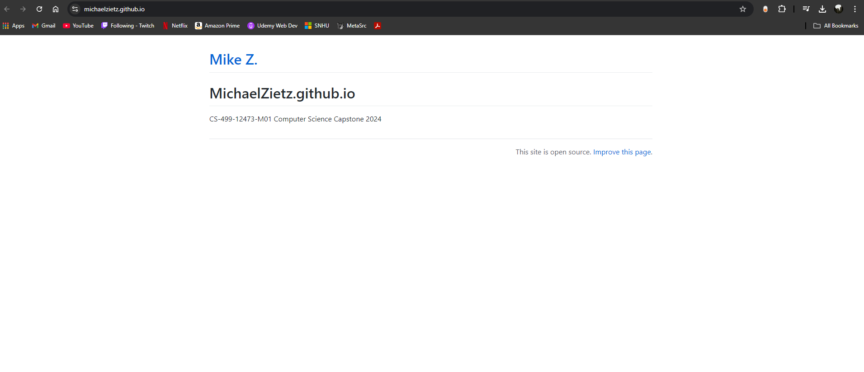

1. **Enhancement Plan:** 
   * **Category One:** Software Engineering and Design
     + **Select an** **artifact** that is **aligned with** **the** software engineering and design **category** and explain its origin. Submit a file containing the code for the artifact you choose with your enhancement plan.

I have selected a previous project I created in Python idependant of my courses at SNHU to enhance. This artifact served as my first dive into studying Python before returning to higher education and completing my bachelor’s in computer science. The project spans three files with a main class and two subclasses.

* + - **Describe** a practical, well-illustrated **plan** for enhancement in alignment with the category, including a pseudocode or flowchart that illustrates the planned enhancement.

The current work is capable of replicating a simplified version of classic table-top gaming combat. It records user input to create one or more characters and weapons with unique properties and simulates the combination of character and weapon damage during their turn using rule systems inspired by Pathfinder by Paizo.

I look to improve the artifact’s functionality through implementing new features, correcting known issues, and improving both the error handling and comments. New feature additions include opponents, with their own sets of properties, for the characters to simulate combat, and a rounds system to challenge the user’s character with procedurally more difficult enemies to face. Between each round, the user will have the option to fight or flee, and once the user is defeated in combat or flees their first time the simulation ends, showing a collection of statistics their character was able to achieve. The final improvement I seek to add is creating a permanent record outside the application’s run instance that saves the user’s highest recorded attempts.

Psuedocode:

1. Implement new enemy class with randomized stats like health and damage
2. Migrate current simulation to separate, new class
   1. Improve simulated comabat to randomly choose enemies for the user’s character to challenge
3. Implement rounds mechanic in combat where the player faces enemies until the user choses to flee or is defeated
4. Increase enemy difficulty via stat increase after each successful round
5. Add the ability to record highest stats achieved in an external file
6. Improve source code error handling and comments throughout the code base

* + - Explain how the planned enhancement will **demonstrate** specific **skills** and align with course outcomes.
      1. Identify and describe the specific skills you will demonstrate that align with the course outcome.

My intention for enhancing this project is to showcase the growth in my software engineering and design skills as a result of my educational pusuits through a before and after snapshot. By implementing more complex software engineering concepts, I seek to illustrate my skills in software design and development. I seek to demonstrate a mastery of Python knowledge and a clear understanding of source code and its components and integrating new features.

* + - 1. Select one or more of the course outcomes below that your enhancement will align with.
* Design, develop, and deliver professional-quality oral, written, and visual communications that are coherent, technically sound, and appropriately adapted to specific audiences and contexts.
* Design and evaluate computing solutions that solve a given problem using algorithmic principles and computer science practices and standards appropriate to its solution while managing the trade-offs involved in design choices.
* Demonstrate an ability to use well-founded and innovative techniques, skills, and tools in computing practices for the purpose of implementing computer solutions that deliver value and accomplish industry-specific goals.

**Course Outcomes Relevant:**

Course Outcomes:

* Employ strategies for building collaborative environments that enable diverse audiences to support organizational decision-making in the field of computer science.
* Design, develop, and deliver professional-quality oral, written, and visual communications that are coherent, technically sound, and appropriately adapted to specific audiences and contexts.
* Design and evaluate computing solutions that solve a given problem using algorithmic principles and computer science practices and standards appropriate to its solution while managing the trade-offs involved in design choices.
* Demonstrate an ability to use well-founded and innovative techniques, skills, and tools in computing practices for the purpose of implementing computer solutions that deliver value and accomplish industry-specific goals.
* Develop a security mindset that anticipates adversarial exploits in software architecture and designs to expose potential vulnerabilities, mitigate design flaws, and ensure privacy and enhanced security of data and resources.
  1. **Category Two:** Algorithms and Data Structures

1. **Select an artifact** that is **aligned with the** algorithms and data structures **category** and explain its origin. Submit a file containing the code for the artifact you choose with your enhancement plan. You may choose work from the courses listed under Category One.

I have selected to enchance the efficiency of the final project worked on in the previous CS 465 Full Stack Development course that which was completed last term. This is a website that includes MEAN full stack functionality, allowing authenticated signing in, database communication, and local hosting services.

1. **Describe** a practical, well-illustrated **plan** for enhancement in alignment with the category, including a pseudocode or flowchart that illustrates the planned enhancement.

I seek to improve the clarity and structure of the project as well as correcting some lingering issues left after its submission. Due to deprecated use of login authorization in the project’s final version, this left an issue with users not being able to submit POST commands to create new or edit existing trip objects after signing in. I seek to implement current tools and APIs used to perform this authentication and enable full functionality to the website developed. I also would like to revisit other pages from the website and implement SQL functionality to other areas other than trip ID management. I plan to implement booking reservations and reconciling availabilities. In its current state, the website is only able to take advantage of a small portion of documented classes and does not separate different types of users signing in. I seek to introduce user roles, those intended to edit trip and those intended to book them, and allow functionality related to them. The website will also need to have features implemented to allow booking once all conditions allow it. Below is a class diagram that depicts the website’s intended complexity but in its current state only delivers a fraction of what is shown:

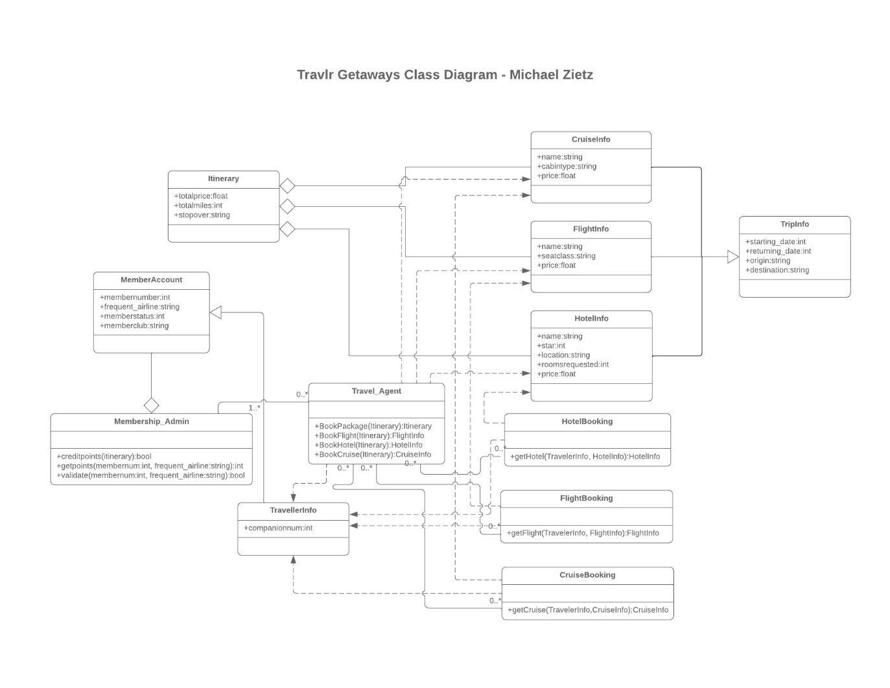

1. **Explain how the planned enhancement will demonstrate specific skills and align with course outcomes.** 
   1. **Identify and describe the specific skills you will demonstrate to align with the course outcome.**

Through the completion of this task, I will display the ability to update existing code structure without fail, locate and resolve areas where functionality has been compromised, and implement new features that do not conflict with an existing codebase. Skills required to successfully implement the user’s roles in the existing structure will require me to include algorithms for identifying those roles and which function they are then able to interact with in the web based platform. If a user does not have the right permissions then they should not be able to interact with it despite being authenticated for login.

* 1. **Select one or more of the course outcomes listed under Category One that your enhancement will align with.**
* Employ strategies for building collaborative environments that enable diverse audiences to support organizational decision-making in the field of computer science.
* Design and evaluate computing solutions that solve a given problem using algorithmic principles and computer science practices and standards appropriate to its solution while managing the trade-offs involved in design choices.
* Develop a security mindset that anticipates adversarial exploits in software architecture and designs to expose potential vulnerabilities, mitigate design flaws, and ensure privacy and enhanced security of data and resources.
  + **Category Three: Databases**
    - **Select an artifact that is aligned with the databases category and explain its origin. Submit a file containing the code for the artifact you choose with your enhancement plan. You may choose work from the courses listed under Category One.**

The third and final artifact chosen to enhance for this ePortfolio is the Grazioso Salvare Search for Rescue Dash application created in CS 340 Client/Server Development. The project, in its current state, hosts a web based platform where the user can sort and show specific dogs based on various criteria from differing rescue centers, a pie chart displays the percentages of each, unique result, and a map interface shows their recorded locations. This artifact utilizes Python to create the dashboard and establish CRUD functionality between the site and a Microsoft Excel document storing the centers’ dog information.

* + - **Describe a practical, well-illustrated plan for enhancement in alignment with the category, including a pseudocode or flowchart that illustrates the planned enhancement.**

I seek to enhance this application’s current GUI, as its pie chart often results in unappealing visuals that clutter the screen, migrate the project, as it was initially created for a virtual lab environment, named Apporto, and recreate it in a Windows OS environment. This will require me to install and coordinate compatible versions of Python and MongoDB. For this application, the PyMongo interface will need to be utilized in order The recreated application must include authentication before allowing access to CRUD features as only specified individuals should be granted permissions to modify stored data. Currently, the credentials are stored within the dashboard, so I will seek to deploy a login process that strengthens the application’s security.

Pseudocode:

1. Perfect the current GUI to remediate flaws and unappealing results

2. Improve the comments and documentation throughout the project files

3. Install necessary drivers and APIs (Python, MongoDB, and PyMongo)

4. Install Jupyter Notebook on my local machine

5. Migrate the existing Jupyter Noteboook files into my Windows OS environment

6. Modify the existing dashboard to include authenticated user login

* + - **Explain how the planned enhancement will demonstrate specific skills and align with course outcomes.** 
      * **Identify and describe the specific skills you will demonstrate that align with the course outcome.**

Through the successful recreation of this application initially designed for Linux OS, I will demonstrate my understanding of the Python language, skills deploying MongoDB and CRUD functionality, and ability to reproduce and recreate scripts inside Jupyter Notebook. It will showcase my understanding of Dash through creating a secure login process before granting access to important data.

* **Select one or more of the course outcomes listed under Category One that your enhancement will align with.**
* Demonstrate an ability to use well-founded and innovative techniques, skills, and tools in computing practices for the purpose of implementing computer solutions that deliver value and accomplish industry-specific goals.
* Develop a security mindset that anticipates adversarial exploits in software architecture and designs to expose potential vulnerabilities, mitigate design flaws, and ensure privacy and enhanced security of data and resources.
* **ePortfolio Overall Skill Set**
  + Accurately describe the **skill set** to be illustrated by the **ePortfolio** **overall**.
    - **Skills and outcomes planned to be illustrated in the code review**

By documenting code reviews for each of the three selected artifacts, I plan to demonstrate robust applications that comply with industry coding standards. I will emphasize my skills in attention to functional code detail as well as secure coding principles. As projects grow in size, it is common for errors, bugs or even vulnerabilities to slip through the testing cracks. These code reviews exist to show my extensive attention and understanding of every line of code in each code base. These code reviews are a necessary portion of development as they provide me with a great opportunity to reflect and revise a program’s structure, performance, logic, and even readability. The greatest outcome of these code reviews will imply less time spent testing for all cases of errors because the most important areas can be identified early on and included in the original development time frame.

* **Skills and outcomes planned to be illustrated in the narratives**

Through the narratives surrounding the three areas: software design and engineering, algorithms and data structures, and databases, I seek to outline the various skills earned and developed throughout my enrollment in SNHU’s computer science program with a concentration in software engineering. I plan to showcase that I have applied data structures for appropraitely organizing data within the given context of many different problems. I seek to display that I have developed and produced robust algorithms that accurately perform defined functions and produce desired outcomes through basic algorithms and shared data structures. I have deployed organizational tactics in recording my approach and lifecycle for developing software that will align with future employer’s desires for detailed documentation, and that I am proficient in analyzing large projects and breaking them into more digestible and solveable problems as well as recognizing and resolving possible vulnerabilities and quality assurance.

* + - **Skills and outcomes planned to be illustrated in the professional self-assessment**

The professional self-assessment will illustrate my entire journey through computer science and explain my reasons not just for pursuing this degree but also my passion for honing and improving my computer science skills surrounding coding and software development. It will seek to display my talents that I’ve shown in my portfolio and my dedication to staying motivated, organized, and adventureous in my pursuits. Through showing proficiency across multiple languages such as Java, Python, C++, and SQL and handon experience with development environments like Jupyter Noteboooks, PyCharm, and Visual Studio Code, I will demonstrate my ability to adapt to any setting in an agile environment. Demonstrating my problem solving skills, troubleshooting, researching, and adhering to best practices will be reflected in my self-assessment and emphasize my eagerness to enter the software development life cycle industry.